**Detection of Liver Cirrhosis Using Fuzzy Expert System**

Jyoti1, Ramandeep Sandhu2*, Kamlesh Lakhwani3 Aarti Shar3

1,2,3, *School of Computer Science and Engineering,

1,2,3,*Lovely Professional University, Phagwara

[jyoti.29569@lpu.co.in](mailto:jyoti.29569@lpu.co.in)1,[Ramandeep.28362@lpu.co.in](mailto:Ramandeep.28362@lpu.co.in)2*, [kamlesh.lakhwani@jecrcu.edu.in](mailto:kamlesh.lakhwani@jecrcu.edu.in),

[aarti.25569@lpu.co.in](mailto:aarti.25569@lpu.co.in)3

**Abstract:** Fibrosis means thickening and scarring of connective tissue, usually as a result of injury or result from a cycle of damage and healing that occurs in the organs. One of the major risk factors for the progression of liver cancer and the cause of unexpected death is liver cirrhosis, the final stage of chronic liver disease. Fuzzy image handling is the gathering of all methodologies that comprehend, speak to and process the pictures, their sections and highlights as fuzzy sets. The portrayal and handling rely upon the chose fuzzy procedure and on the issue to be resolved.This paper shows that this can be diagnosed by using fuzzy logic under image processing.

*Keywords* — F*ibrosis, Fuzzy rules , cirrhosis, Scarring, Chronic.*

# **Introduction**

In the overall scale, live disease remains the third most normal reason for malignant growth related passings and the fifth-most regular malignant growth. Conclusion and treatment of Hepatitis B or Hepatitis C ailment relies upon the assurance of the fibrosis arrange from F0 (no harm) to F4 (cirrhosis) [1]. Patients with cirrhosis require complex prescriptions including hospitalization prompting a general yearly cost of over $2.5 billion in the United States alone. This stage can be guided by liver biopsies where a limited quantity of tissue is expelled by a specialist and analyzed by a pathologist, however biopsies are expensive and convey some hazard for the patient. Different strategies are the non-obtrusive, which use serum markers, imaging test, and hereditary investigations. Be that as it may, their exactness’s have not accomplished adequate acknowledgment. Sickness finding is made increasingly complex on the grounds that a great deal of dubiousness and vulnerability are included. Patients are consistently not ready to depict precisely what has befallen them or how they feel. Doctors may not comprehend or translate precisely what they hear, and patients may have questionable indications and signs. Lab test reports may accompany some level of blunder, and therapeutic specialists are not ready to decisively decide how illnesses modify the ordinary working of the body. It isn't sensible to speak to this information as far as fresh qualities. Furthermore, every patient may have a lot of authentic information, yet doctors have no opportunity to check and examine every one of them. It is exceptionally basic to land at the most exact therapeutic conclusion in an auspicious way since snappy and precise analysis and convenient inception of treatment is imperative to decrease both potential difficulties and expenses.

# **Problem of Liver Cirrhosis**

Cirrhosis is major reason for grimness and fatality in progressively created nations, being the fourteenth generally normal reason for death worldwide however fourth in focal Europe [2]. Progressively, cirrhosis has been believed to be not a solitary malady element, however one that can be sub classified into particular clinical prognostic stages, with 1-year mortality going from 1% to 57% contingent upon the stage. We survey the present comprehension of cirrhosis as a powerful procedure and diagram current helpful alternatives for counteractive action and treatment of intricacies of cirrhosis, based on the Sub classification in clinical stages. The new idea in the executives of patients with cirrhosis ought to be anticipation also, early mediation to settle sickness movement and to stay away from or postpone clinical compensation and the requirement for liver transplantation. The test in the 21st century is to anticipate the requirement for liver transplantation in the same number of patients with cirrhosis as could be expected under the circumstances. In Condition of Cirrhosis, the working of liver is not able of performing functions properly in light of whole deal hurt. The presence of scar tissue in place of normal liver tissue serves to illustrate this damage. The condition typically worsens over the course of several months or years.At the starting stage, there are no negative consequences. As the malady exacerbates, an individual may endup worn out, feeble, bothersome enlarge the lower legs, produce yellow skin, effectively heal wounds, have liquid form in the midsection, or produce arachnid-like veins on the skin. The mid-regional liquid development could result to be precipitously contaminated. Other real complications include hepatic encephalopathy, leaking from larger neck veins or expanded stomach veins., and liver malignant growth.

# **Liver Disfunction**

The following highlights are a direct result of dysfunctional liver cells:

• Spider angiomata, also known as spider nevi, are vascular lesions caused by an increase in estrogen that consist of a focal arteriole surrounded by several smaller arteries (hence the name "bug"). According to one investigation, insect angiomata occur in about one-third of cases.[2]

•Due to the increased estrogen, palmar erythema causes the skin around the thenar and hypothenar eminences to flush.

•Expanded estradiol causes gynecomastia, or an increase in male breast organ size that isn't cancerous, which can occur in up to 2/3 of patients. This is distinct from an increase in breast fat in overweight individuals.[2]

•Hypogonadism, a decline in male sex hormones, can be caused by intrinsic gonadal damage or the concealment of hypothalamic/pituitary capacity and manifest as incompetence, fruitlessness, lack of sexual drive, and testicular degeneration. Alcohol consumption or hemochromatosis are linked to hypogonadism and cirrhosis. [2]

•People with cirrhosis may have an expanded, normal, or contracted liver.

• "Flank bluntness" is made possible by ascites, a collection of fluids in the peritoneal depression (space in the midriff). This might be seen as an increase in stomach size.

•Fetor hepaticus, which is caused by enlarged dimethyl sulfide, is a foul breath odor.

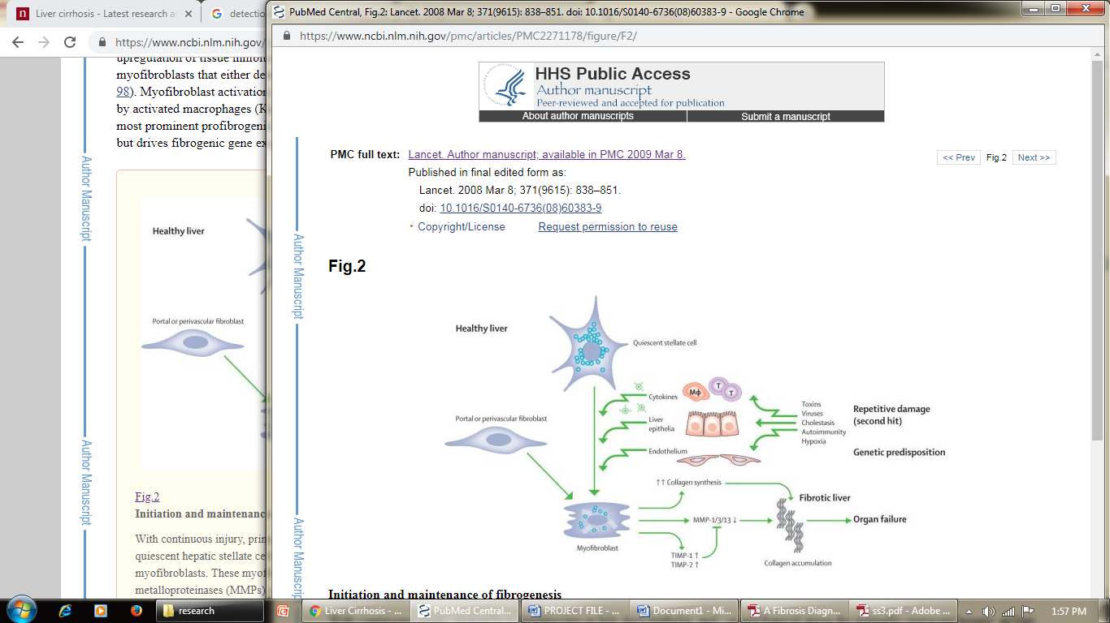• Jaundice, also known as icterus, is characterized by yellow staining of the skin and mucous membranes (the white of the eye is especially noticeable), which is caused by elevated bilirubin levels (at least 2-3 mg/dl or 30 mol/l). The pee could also appear faint.

**Fig. 1:A chart showing percentage chances of getting liver cirrhosis as per the stated causes.[3]**

# **Causes and Diagnosis of Liver Cirrhosis**

## Causes of cirrhosis:

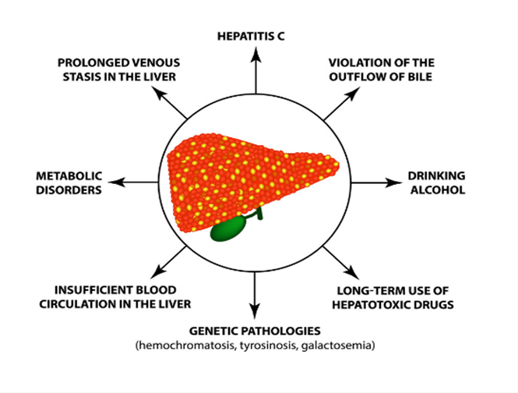

**Fig.2:Causes of Liver Cirrhosis [4]**

Liver cirrhosis has numerous potential causes; in some cases, more than one reason is available in a similar individual. All around, 57% of cirrhosis is inferable from either hepatitis B (30%) or hepatitis C (27%). Liquor utilization is another significant reason, representing about 20% of the cases.

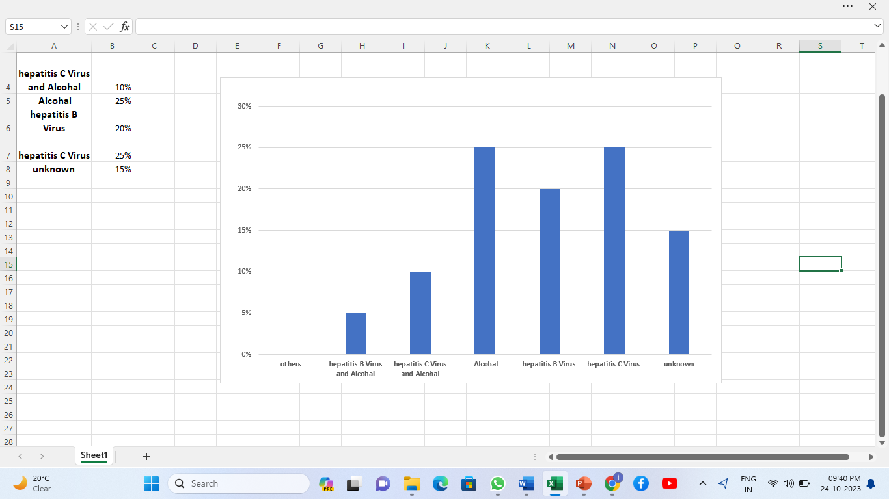

**Fig. 3: A chart showing percentage chances of getting liver cirrhosis as per the stated causes.[3]**

## Diagnosis of cirrhosis:

Specialists analyze cirrhosis dependent on your restorative history, a physical test, and the consequences of tests.

1. *Restorative history*

Your PCP will get some information about your manifestations. The individual in question will likewise inquire as to whether you have a background marked by wellbeing conditions that make you bound to create cirrhosis. Your specialist will get some information about your utilization of liquor and over-the-counter and physician recommended medicines. Patient restorative history form. Your specialist will get some information about your history of wellbeing conditions.

1. *Physical test*

Your primary care physician will analyze your body, utilize a stethoscope to tune in to sounds in your stomach area, and tap or push on explicit territories of your belly. The person in question will verify whether your liver is bigger than it ought to be. Your primary care physician will likewise check for delicacy or torment in your belly.

1. *Blood tests*

Your primary care physician may suggest the accompanying blood tests liver tests that can demonstrate irregular liver catalyst levels, which might be an indication of liver harm. Your primary care physician may speculate cirrhosis on the off chance that you have expanded degrees of the liver compounds alanine transaminase (ALT), aspartate transaminase (AST), and basic phosphatase (ALP) expanded degrees of bilirubin diminished degrees of blood proteins complete blood tally , which can give indications of disease and paleness that might be brought about by interior draining tests for viral contaminations to check whether you have hepatitis B or hepatitis C blood tests for immune system liver conditions, which incorporate the antinuclear neutralizer (ANA), hostile to smooth muscle counter acting agent (SMA), and against mitochondrial immunizer (AMA) tests Based on the blood test outcomes, your primary care physician might be capable analyze certain reasons for cirrhosis. Your specialist can utilize blood tests to tell how genuine your cirrhosis is.

# **Fuzzy Modeling And Working**

The cornerstone of the fuzzy interference system that transforms the input variable (a sharp value) into the fuzzy variable for the prediction of the actual stage of a disease is fuzzy rules and fuzzy analysis. Fuzzy IF ELSE rules are constructed using input (antecedents) and output (consequential) variables in the way IF A (INPUT) THEN D (OUTPUT), where A and D both contain some explicit information pertaining to each input and output parameter. The medical decision-making system used in this paper is simulation-connected, and it is carried out using the fuzzy toolbox in the MATLAB 2013B software. This proposed approach is used to forecast liver cirrhosis detection. The system uses one output variable and four input variables to determine the cirrhosis diagnosis. Yellowing of the skin and eyes (jaundice), stomach ache and edema, swelling around the ankles and legs. skin that itch dark hue of urine pale hue of the stool ongoing exhaustion, vomit or nausea, decrease in appetite, inclination to bruise readily are all indicators of the amount of input. Each input characteristic has a two- or three-trapezoidal membership function relationship. The Mamdani inference system is used for diagnosis because it functions like mortals and has the potential to be extremely knowledgeable. has the ability to handle applications found in the real world.

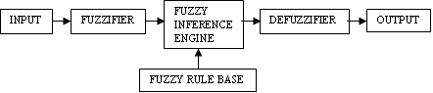

**Fig.4: Steps of Fuzzy Modeling**

# **Results And Discussion**

Fuzzy master framework for the hazard recognizable proof of the Cirrhosis has been created. The created framework is utilized to assess the investigation of twenty patients. It is discovered that the outcomes acquired are in as far as possible set by the area master.For Liver Cirrhosis, three parameters taken into consideration are as under:

1. ALT/AST Ratio
2. PT INR
3. PLT

Depending on the values of the above stated parameters the detection is done.

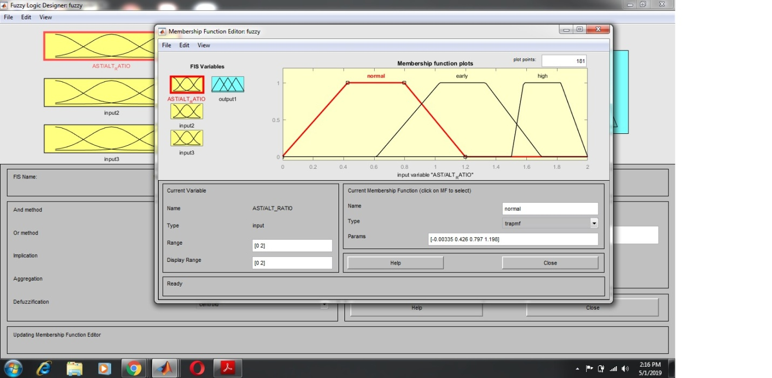

**Fig. 5: Assigning Values To ALT/AST Ratio**

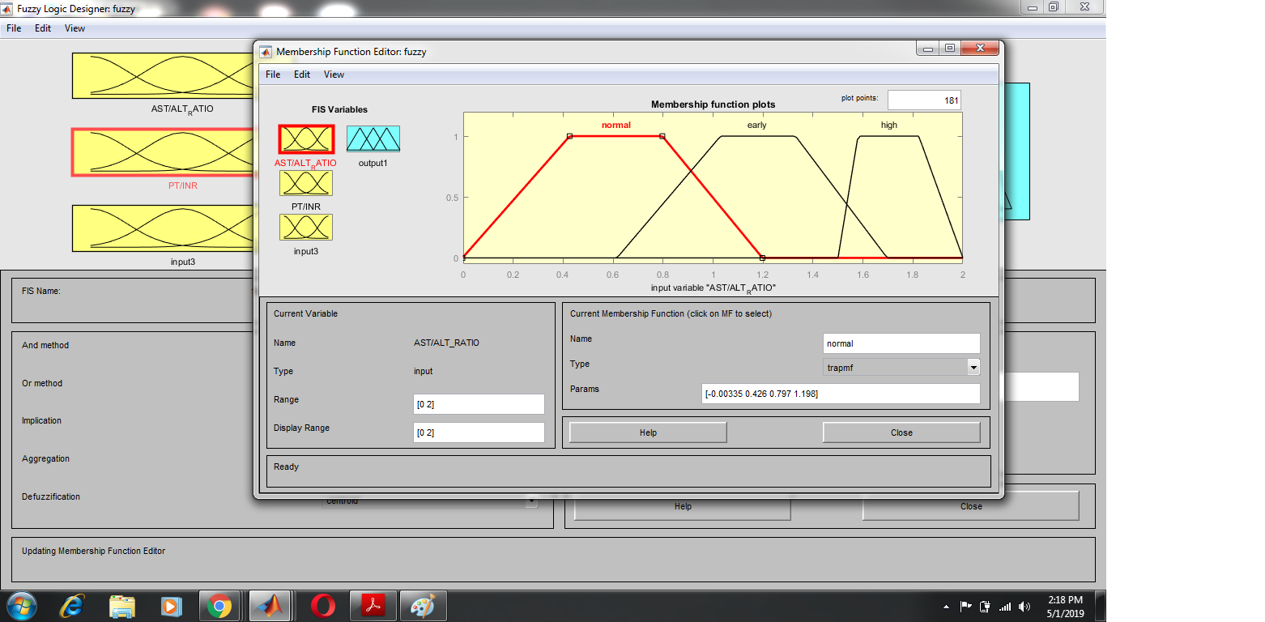

**Fig. 6: Assigning Values to PT/INR**

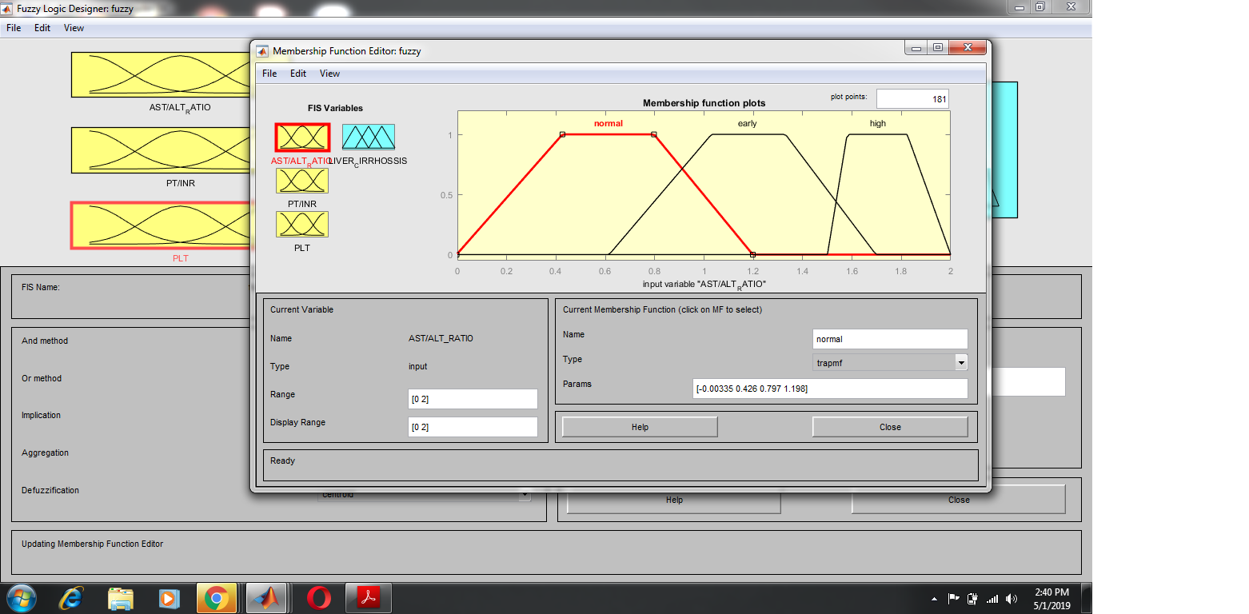

**Fig. 7: Membership Function Plot**

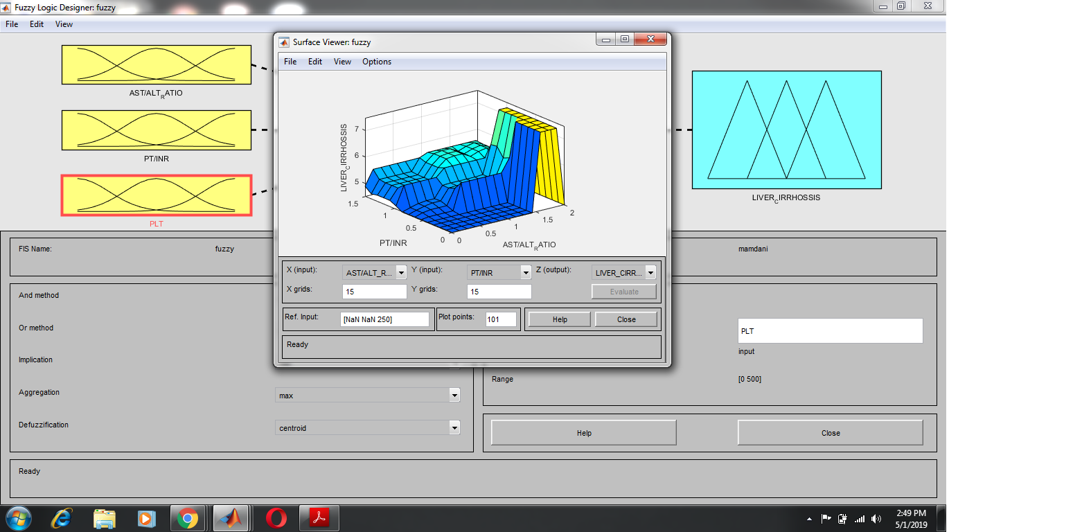

**Fig. 8: Surface View**

In Fig. 5 and Fig. 6, the input parameters such as ALT/AST ratio and PT/INR, respectively, are given to FIS. After that the variables of membership function are designed in Fig. 8. As a result, the output in surface plot is shown in Fig.8 which compares the various levels of disease according to designed fuzzy rules.

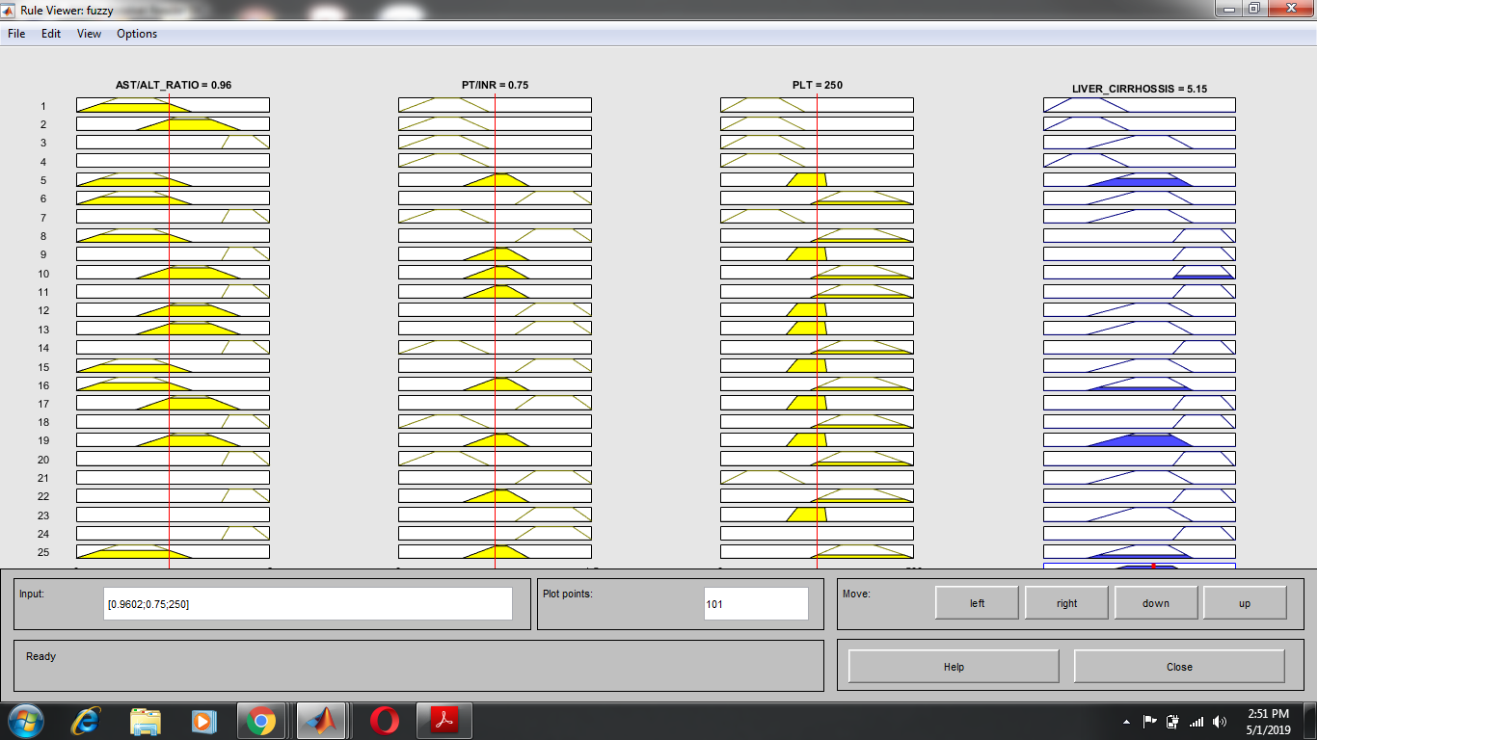

**Fig. 9: Rule Viewer**

Fig. 9 indicates the results of the proposed system which shows the different levels of liver cirrhosis that has been diagnosed using fuzzy expert system.

# **Conclusion**

This examination portrayed the relevance of a fuzzy master framework in diagnosing liver fibrosis with its various stages, even at the primary degree of liver cirrhosis. It very well may be estimated as the recurrence (for example frequency and commonness) of a condition or its belongings including: deadly and non-lethal wellbeing misfortune from malady (for example incapacity balanced life years (DALYs)) just as the money related expenses (for example direct human services costs and circuitous medicinal services uses identified with lost salary because of unexpected passing). The system depends on an interpretable learning base, which considers both master information and learning extricated from information. We proposed another information-based framework for forecast of liver fibrosis stages utilizing a fuzzy thinking. This examination proposes a fuzzy fibrosis choice emotionally supportive network. It is a fuzzy learning-based master framework for liver fibrosis organize forecast. F2DS is painstakingly founded on a lot of information securing and AI methods. What's more, the framework relies upon space master information for structuring the participation capacities and approving the fuzzy learning base. There is still a lot of work to do to improve liver fibrosis conclusion.

**References**

1. Dame Sheila Sherlock , ”Alcoholic liver disease” The Lancet, Volume345, Issue 8944, Pages 227-229, (1995)
2. Hyung Joon Yim and Anna Suk-Fong Lok,” Natural History of Chronic Hepatitis B Virus Infection: What
3. We Knew in 1981 and What We Know in 2005”, HEPATOLOGY, Pages 173-181, (2006)
4. “Fatty Liver Disease”, Available online at http://www.webmd.com/hepatitis/fatty-liver-disease.
5. Anthony S. Tavill, “ Diagnosis and Management of Hemochromatosis”, Hepatology, Pages 1321-1328, (2001)
6. Gurung RB, Purbe B, Gyawali P, Risal P “The Ratio of Aspartate Aminotransferase to Alanine Aminotransferase(AST/AST): the correlation of value with Underlying Severtity of Alcoholic Liver Disease”, KATHMANDU UNIVERSITY MEDICAL JOURNAL, VOL.11, PAGES 233-236, (2013)
7. Tripodi A, Chantarangkul V, Primignani M, Fabris F, Dell'Era A, Sei C, Mannucci PM. “The international normalized ratio calibrated for cirrhosis (INR(liver)) normalizes prothrombin time results for model fo end-stage liver disease calculation”,Hepatology ,Pages: 520-527,(2007).
8. Liu XD, Wu JL, Liang J, Zhang T, Sheng QS, “ Globulin-platelet model predicts minimal fibrosis and cirrhosis in chronic hepatitis B virus infected patients” ,World J Gastroenterol, Pages: 2784-92(2012).
9. Dana Crisan1, Corina Radu1, Mircea Dan Grigorescu, Monica Lupsor, Diana Feier1, Mircea Grigorescu1, “Prospective Non-Invasive Follow-up of Liver Fibrosis in Patients with Chronic hepatitis C J Gastrointestin Liver Dis”, Vol.21, (202),Pages 375-382